What are the chances that WinSCP could uses the wrong userid to connect to a remote host?
WinSCP version 6.3.3
We had a one-time occurrence with a client connection that try to connect to a remote host with the wrong user id and we are looking for root cause.
The connection is started by a task in the task scheduler which in turn runs a batch that calls the connection in WinSCP.
All information pertaining to the client have been removed and using fictitious names.
Please forgive me for asking this unreasonable question but like I mentioned we need a root cause:
What are the chances that WinSCP by itself changes the user ID for the connection. As shown below:
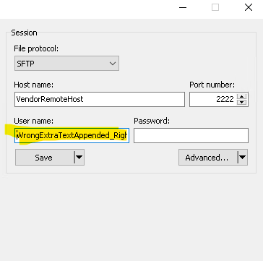

As per vendor in this only instance where connection failed, the wrong ID was used to try to connect to their site using the authentication method of: publickey,password. Since I cannot provide full details, let say use this information:
Failed attempt with wrong user id and authentication method being used is public and password.:
2024-02-07 05:00:02.424 Host key matches cached key
. 2024-02-07 05:00:02.424 Initialised AES-256 SDCTR client->server encryption
. 2024-02-07 05:00:02.424 Initialised HMAC-SHA-256 client->server MAC algorithm
. 2024-02-07 05:00:02.424 Initialised AES-256 SDCTR server->client encryption
. 2024-02-07 05:00:02.424 Initialised HMAC-SHA-256 server->client MAC algorithm
! 2024-02-07 05:00:02.565 Using username "WrongExtraTextAppended_Right_UserID".
. 2024-02-07 05:00:02.612 Server offered these authentication methods: publickey,password
. 2024-02-07 05:00:02.612 Prompt (password, "SSH password", <no instructions>, "&Password: ")
. 2024-02-07 05:00:12.671 Disconnected: Unable to authenticate
Failed attempt with wrong user id userid: WrongExtraTextAppended_Right_UserID, authentication complete: false, EVENT: -16,776,961 - EVENT_DISCONNECTED

In this is the log where connection was successful (with the Right User ID and authentication method Public Key.
. 2024-02-07 12:16:47.984 Host key matches cached key
. 2024-02-07 12:16:47.984 Initialised AES-256 SDCTR client->server encryption
. 2024-02-07 12:16:47.984 Initialised HMAC-SHA-256 client->server MAC algorithm
. 2024-02-07 12:16:47.984 Initialised AES-256 SDCTR server->client encryption
. 2024-02-07 12:16:47.984 Initialised HMAC-SHA-256 server->client MAC algorithm
. 2024-02-07 12:16:48.097 Reading key file "X:\_Folder\SubFolder\Client_Private Key_2.ppk"
! 2024-02-07 12:16:48.097 Using username " Right_UserID ".
. 2024-02-07 12:16:48.143 Server offered these authentication methods: publickey
. 2024-02-07 12:16:48.143 Offered public key
. 2024-02-07 12:16:48.300 Offer of public key accepted
! 2024-02-07 12:16:48.300 Authenticating with public key "Client_SSH-RSA-KEY 2048 MM/DD/YYYY"
. 2024-02-07 12:16:48.378 Sent public key signature
. 2024-02-07 12:16:48.425 Access granted
. 2024-02-07 12:16:48.425 Opening session as main channel
. 2024-02-07 12:16:48.472 Opened main channel
. 2024-02-07 12:16:48.652 Started a shell/command

