How to Import Session into Windows Registry
- Create a template session from WinSCP
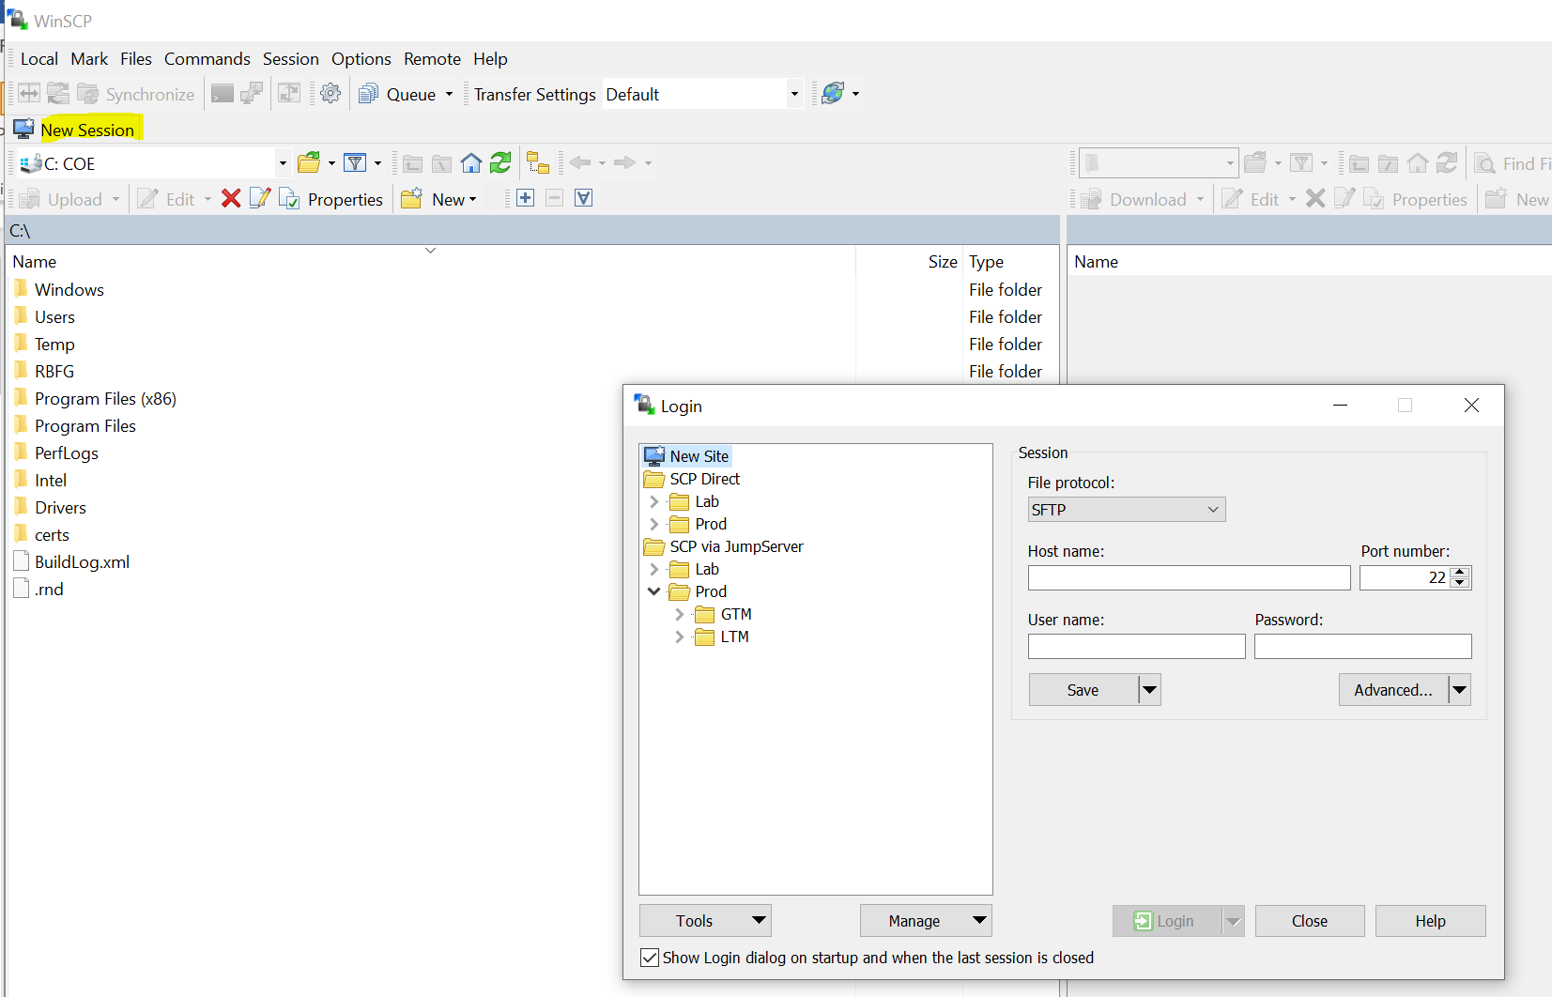
- Go to Windows Registry \HKEY_CURRENT_USER\SOFTWARE\Martin Prikryl\WinSCP 2\Sessions to export the session configuration to a test_template.reg file:
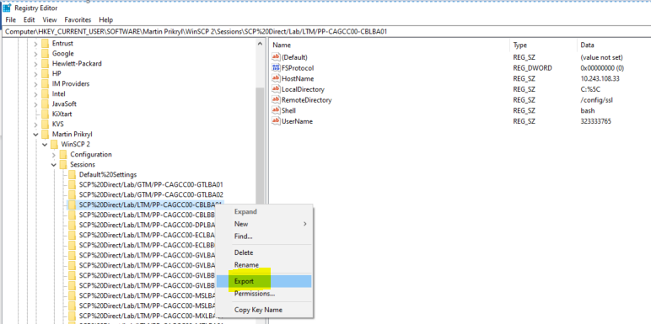
- Create a new reg configuration from the template test_template.reg, such as for device name TEST_DEV_01, and IP is 9.9.9.9.
- Go to Windows Registry to import TEST_DEV_01.reg, then you will the registry config was added.
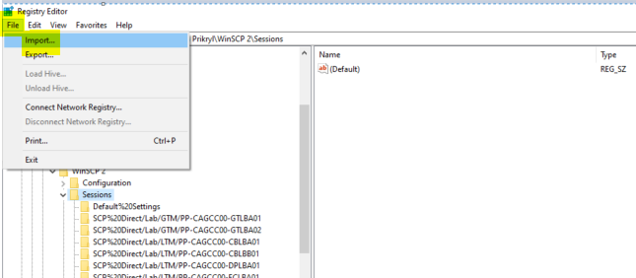

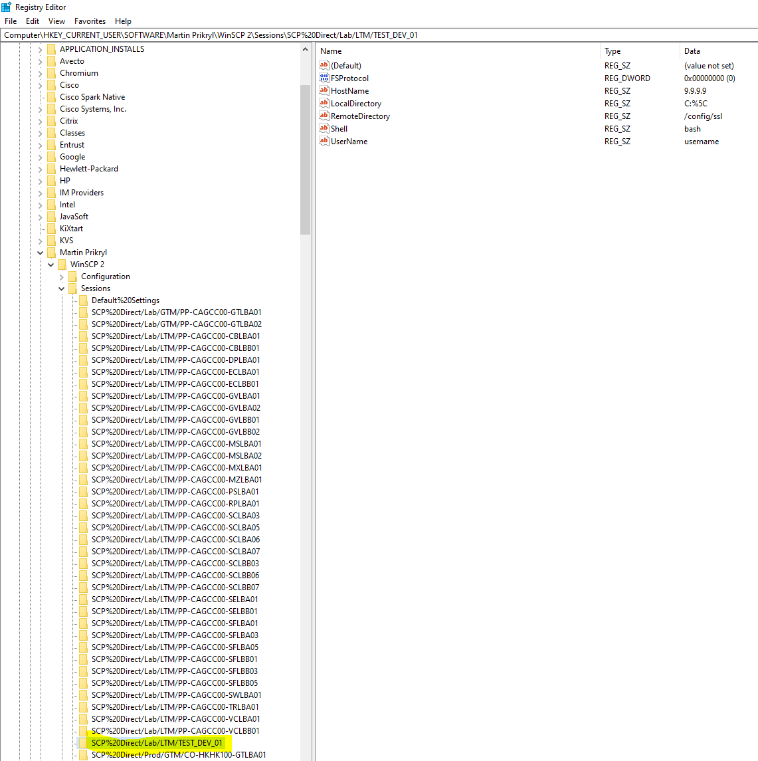

- Go to WinSCP and Click New Session or New Tab, then you will the session was imported from Windows Registry and you can make connection, this works fine with v5.21.7 and I can create hundreds registry session config based on the registry template by Python and imported into registry, but it does not work for v6.1, on v6.1 afer imported from registry it just shows the top level folder which is SCP Direct, no subfolder Lab and LTM and session TEST_DEV_01 showed up.
