WinSCP file transfer Issues:
Robin Screenshots:
These are the screenshots of the “failed” message when uploading files
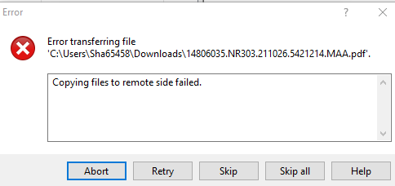

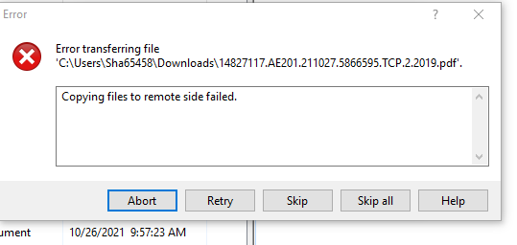

The Size of transferred file is in Zero KB
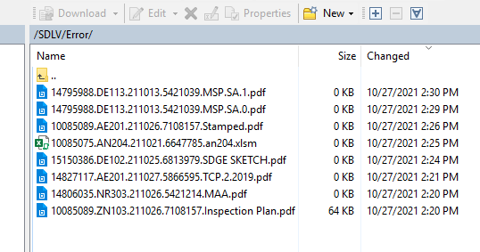

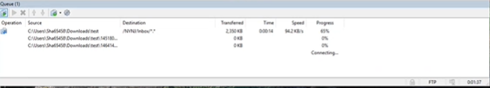

Error:
Error Transferring the file:
Copying files to remote side failed
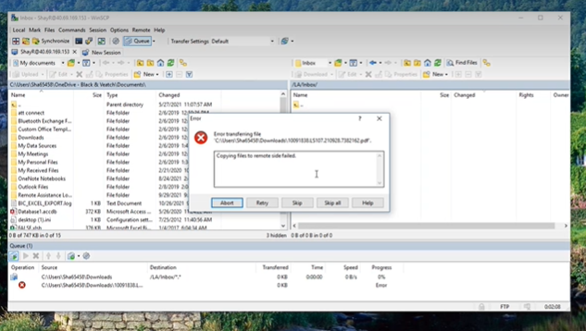

Error:
Error listing directory ‘/LA/Inbox
Could not retrieve directory listing
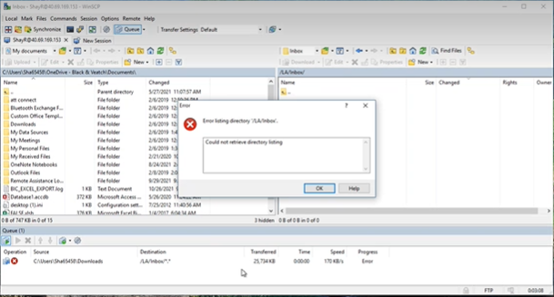

Eric Screenshots:
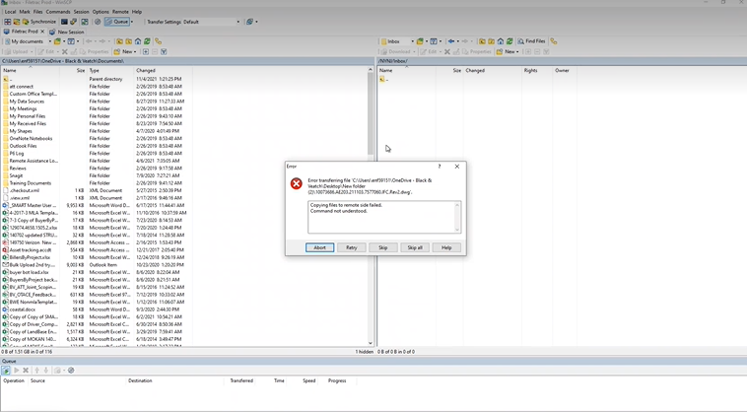

Timeout detection:
