Uploading config.bin, .cli and/or firmware to DOM using WinSCP

Link to the DO-EMS: https://10.142.250.29:8443/

Once you login click on DOEMS-PANELS then click on DOM and it will list all the DOM’s in the network.

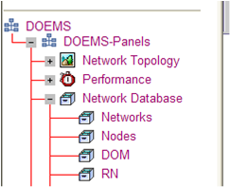

In the bottom left corner there is a link called “Run Fault Client” hit this and it will show all the active DOM card alarms on the system.

If you have questions once you login let me know.
1 – Click on DOEMS-Panels
2) Select – System Administration
3) Select – NE Files
4) On “Configbin” line click on CD
5) Find the IP of the DOM and click on CD
6) Save to your machine

  - Laptop Provisioning for DOM Communication:
SecureCRT Serial Connection Properties:
Baud Rate: 38400
Data bits: 8
Parity: None
Stop bits: 1

Check Flow Control: XON/XOFF

Ethernet Connection Properties:
Local Area Connection properties - Internet Protocol (TCP/IP) properties:
Use the following IP address: 192.100.100.100 Subnet: 255.255.255.0

  - Provisioning Ethernet Port on DOM:
            - Connect to DOM with serial connection
- Give the Ethernet interface an IP address of 192.100.100.001/24:
- Username: default Password:!default (or 1nortel)

Enable Mode:

Nortel-XX>enable

Configuration Mode:

Nortel-XX#config

Interface ethernet1/0/1

Nortel-XX#(config)Interface ethernet1/0/1

Ip address 192.100.100.1/24

Nortel-XX#(config-if)ip address 192.100.100.1/24

No shut

Nortel-XX#(config-if)no shut

- Exit back to enable prompt by typing exit until you are at Nortel-XX# enable prompt. Save this configuration with write command:

Nortel-XX#write

This will write our information to the cards memory and save it.

  - Upload config.bin to DOM using WinSCP:

  - Connect an Ethernet cable to Ethernet port on the DOM and Ethernet port on the PC.
  - Launch WinSCP (WinSCP can be downloaded from EDN’s Software Center)
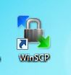
- When WinSCP opens you will get the following screen (your Login window will most likely show just the New Site in the left window pane):
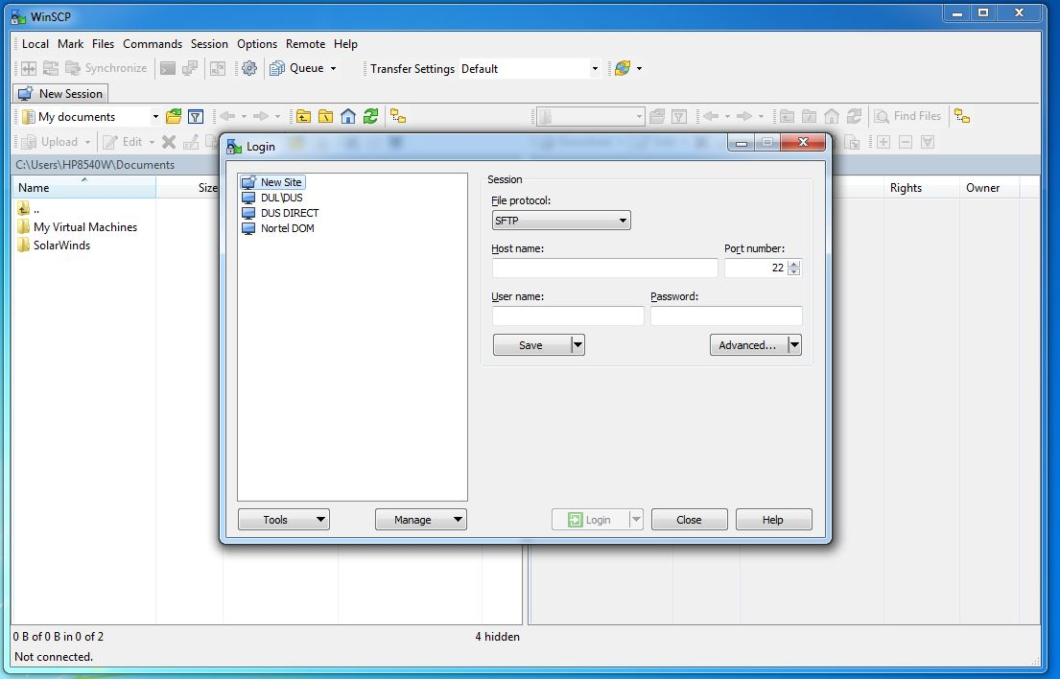

- File protocol will be left at SFTP. Put in 192.100.100.1 (the IP address you set your Ethernet1/0/1 port to) in the Host name field. Username will be default. Password will be 1nortel. See example screenshot below. ***One note: At this time you could save this login setup for the next time you need to transfer files to a DOM. Select Save and a window will popup where you can name your session. This will be placed in the window to the left and can be selected next time and it will have all your IP and login information you saved populated***
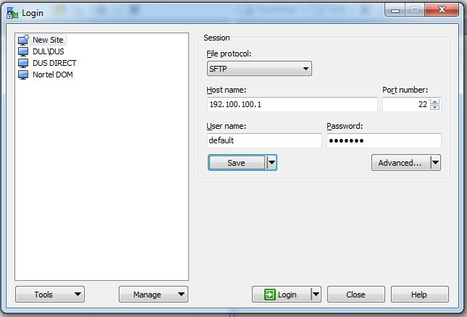

- Click the Login button. WinSCP will connect to the DOM. If your connection is successful you will see your computer’s directories/files shown on the left side of the window (local), and the DOM’s disk0:/ directories shown on the right side of the window (remote). Screenshot below shows an example of WinSCP connected to the DOM.

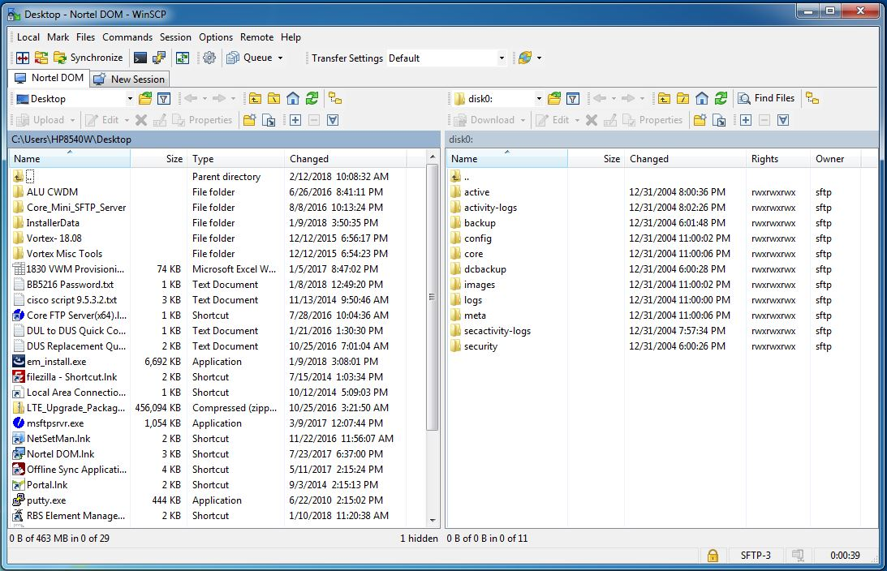

- To transfer the config.bin file you have to the DOM follow these steps.
  - Set your transfer setting to binary. At the top of the window and centered is the Transfer Settings box. Use the dropdown and set it to Binary.
  - On the left half of the window, navigate to the directory where you placed the config.bin file on your computer and select the config.bin file.
  - Once you have selected the config.bin file, the Upload icon just above the window will become enabled. See screenshot below.
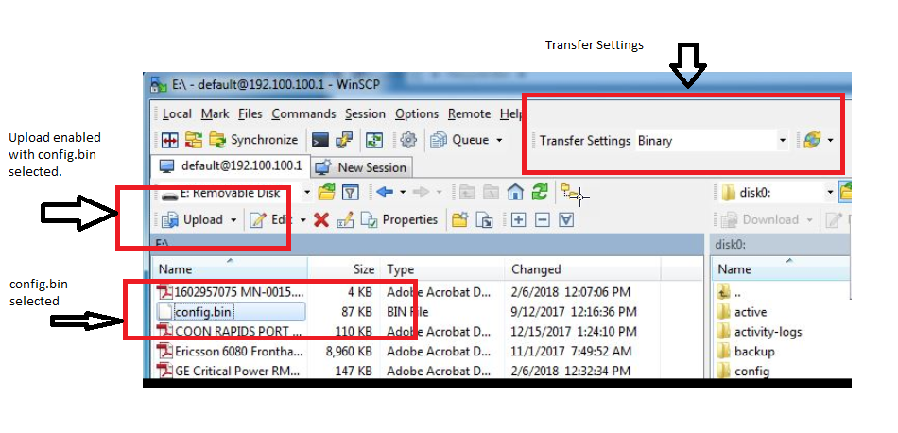
  - Click on the Upload icon. The Upload window will open.

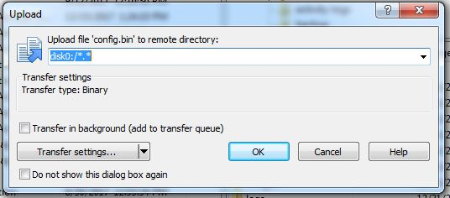

  - disk0:/*.* will be highlighted. Remove this from the window leaving it blank as in the example screenshot below. Double check your transfer setting is set to Binary.
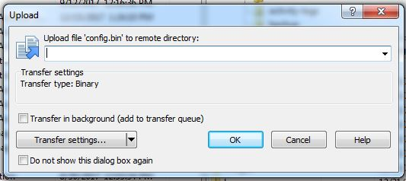

  - With the Upload file box blank. Press OK and the config.bin file will be transferred to the DOM.
  - You should now see the config.bin file you just transferred on the right half of the window (remote/DOM side) under the DOM’s directories.

  - Reboot DOM with the new config.bin file using serial connection, SecureCRT and in enable mode:

Nortel-XX#reboot config disk0:/config.bin

