WinSCP-5.13.3
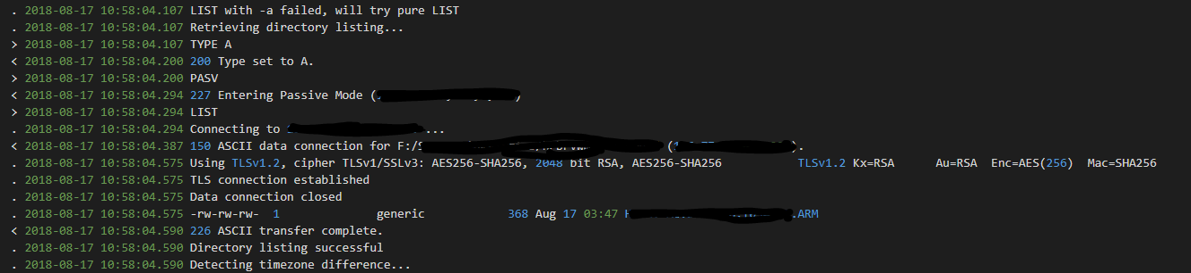
WinSCP-5.5.6
From the same file with the same timestamp as WinSCP-5.13.3 for ease of comparison.
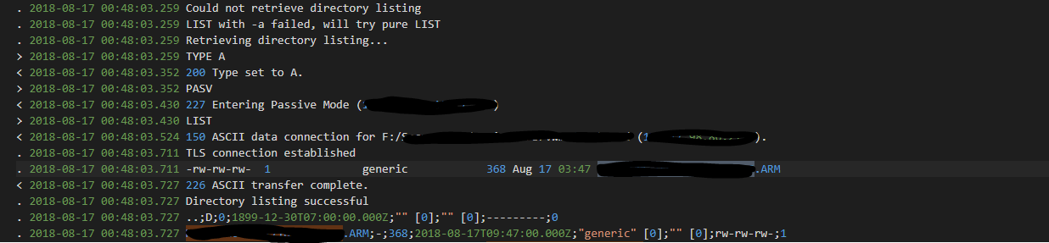
WinSCP-5.5.6
