WinSCP-5.13.3
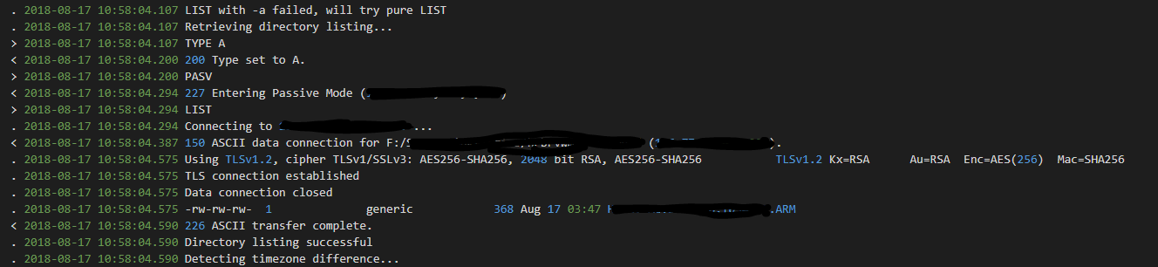
WinSCP-5.5.6


